Translated from Polish to Lithuanian - www.onlinedoctranslator.com
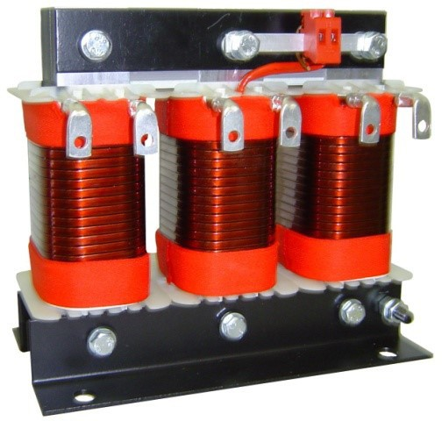
NORMOS IR STANDARTAI
transformatoriaus parametrai atitinka Europos standarto reikalavimus
EN / IEC 61558

3RTR-14 %
480V trifazis rezonansinis droselis
PAPILDOMA INFORMACIJA
rezonansiniai droseliai parenkami individualiai kiekvienai kompensavimo pakopai, atsižvelgiant į kondensatoriaus vardinę įtampą, jo vardinę galią ir reikiamą rezonanso dažnį

PASKIRTIS IR KONSTRUKCIJA
Rezonansiniai droseliai skirti veikti reaktyviosios galios kompensavimo sistemose
Jie montuojami nuosekliai su talpine baterija, sukuriant rezonansinę grandinę, kuri apsaugo kondensatorius nuo perkrovos
tokia sistema riboja srovės harmonikų amplitudes ir sumažina rezonanso riziką
Šio sprendimo efektyvumą lemia teisingas reaktoriaus parametrų pasirinkimas

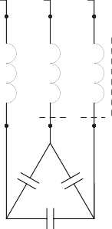
ELEKTROS SCHEMA
TECHNINIAI PARAMETRAI
Techniniai standartai | EN 60076-6; EN 61558-2-20
Kondensatoriaus galia | Nuo 2,5 iki 60 kVAr
Tinklo įtampa | 400 V (maks. + 10 %)
Akumuliatoriaus vardinė įtampa | 480 V.
Slopinimo koeficientas [p] | 14 % (134 Hz)
Dažnis | 50 Hz
Saugumo lygis | IP00
Izoliacijos klasė | F pagal nutylėjimą
Aplinkos temperatūra | -25⁰C iki +40⁰C
Magnetinis tiesiškumas | I = 1,2 colio
Šiluminė srovė | Ith = 1,06 colio
Įranga | Terminis jungiklis AM03.140
Elektros gnybtai | spaustukai / galai / bėgiai
Mechaninis surinkimas | įsukite per kampus

3 RTR

AKUMULIATORIUS

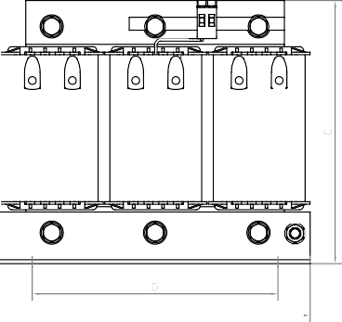
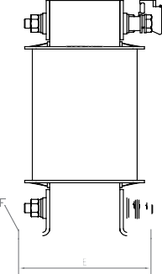
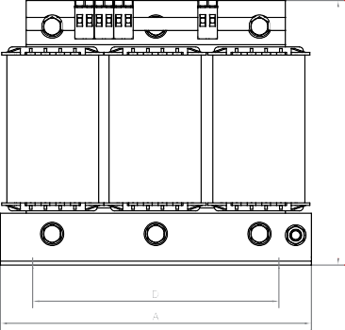
Techniniai matmenys

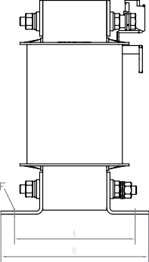
Dizainas A |  |  |  |  | Vykdymas B

MATMENŲ LENTELĖ
Tipas | Baterijos galia | Elektra | Indukcija. | Nuostoliai | IR | B | C. | D | E. | F. | Mišios
 |  |  |  |  |  |  |  |  |  |  |  | Gnybtai
 | [kVAr] | [IR] | [mH] | [IN] | [mm] | [mm] | [mm] | [mm] | [mm] | [mm] | [kilogramas]
3RTR-2.5 / 48014 | 2.5 | 2.9 | 41.07 val | 55 | 155 | 77 | 130 | 130 | 57 | 8*12 | 3.4 | RKW-14/2
3RTR-5.0 / 48014 | 5.0 | 5.8 | 20.53 val | 90 | 155 | 92 | 130 | 130 | 72 | 8*12 | 5.5 | RKW-14/2
3RTR-7.5 / 48014 | 7.5 | 8.7 | 13.68 | 94 | 210 | 98 | 180 | 165 | 78 | 8*12 | 8.7 | RKW-14/2
3RTR-10/48014 | 10 | 11.7 | 10.27 | 98 | 210 | 105 | 180 | 165 | 85 | 8*12 | 10.7 | BTF-4
3RTR-12.5 / 48014 | 12.5 | 14.6 | 8.21 | 115 | 210 | 115 | 180 | 165 | 95 | 8*12 | 12.5 | BTF-4
3RTR-15/48014 | 15 | 17.5 | 6.84 | 148 | 240 | 121 | 205 | 190 | 95 | 11*15 | 13.7 | K90R-10/6
3RTR-20/48014 | dvidešimt | 23.3 | 5.13 | 164 | 240 | 141 | 205 | 190 | 115 | 11*15 | 19.2 | K90R-10/6
3RTR-25/48014 | 25 | 29.1 | 4.11 | 174 | 240 | 155 | 205 | 190 | 129 | 11*15 | 23.2 | K90R-16/6
3RTR-30/48014 | trisdešimt | 35 | 3.42 | 207 | 240 | 155 | 205 | 190 | 129 | 11*15 | 24.4 | K90R-16/6
3RTR-40/48014 | 40 | 46.6 | 2.57 | 307 | 300 | 165 | 260 | 240 | 133 | 11*15 | 32.7 | K90R-25/8
3RTR-50/48014 | 50 | 58.3 | 2.05 | 346 | 300 | 177 | 260 | 240 | 145 | 11*15 | 37.0 | K90R-25/8
3RTR-60/48014 | 60 | 69.9 | 1.71 | 357 | 300 | 192 | 260 | 240 | 160 | 11*15 | 43.8 | K90R-35/8
3RTR-90/48014 | 90 | 104.9 | 1.14 | 452 | 360 | 193 | 310 | 300 | 165 | 11*15 | 78.8 | Cu 20x5

Gnybtai

 | Tipas | RKW-14/2
 | Skerspjūvis | iki 4,0 mm2
 | Apkrova | iki 32 A.
 | Priveržimo momentas | 0,8 Nm

 | Tipas | BTF-4
 | Skerspjūvis | iki 4,0 mm2
 | Apkrova | iki 32 A.
 | Priveržimo momentas | 1,5 Nm

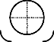 | Tipas | K90R-10/6 | K90R-16/6 | K90R-25/8 | K90R-35/8
 | Skerspjūvis | 10 mm2 | 16 mm2 | 25 mm2 | 35 mm2
 | Apkrova | iki 40 A. | iki 50 A. | iki 75 A. | iki 120 A.
 | Varžtas / sukimo momentas | M6 / 9,5 | M6 / 9,5 | M8 / 23 | M8 / 23

 | Tipas | Cu 15x3 | Cu 20x5
 | Skerspjūvis | 45 mm2100 mm2
 | Apkrova | 120 A260 IR
 | Varžtas / sukimo momentas | M6 / 9,5M8 / 23

